Activity No. 1 Getting Started with React Native
Course Code: CPE 025B | Program: Computer Engineering
Course Title: Software Design 2 | Date Performed: 03/27/26
Section: CPE32S1 | Date Submitted: 03/27/26
Name: Edson Ray San Juan | Instructor: Engr. Neil Matira
1. Objective(s)
This activity aims to enable students to build a basic application with local state management and Create React Native App.
2. Intended Learning Outcomes (ILOs)
After this module, the student should be able to:
- Configure a React Native development using the Expo Go environment;
- Deploy a live-demo of a mobile application on both iOS and Android.
3. Discussion
There are two common ways to set up a React Native development environment: expo-cli and react-native CLI.
expo-cli
This is a command-line utility for configuring and publishing React Native projects. This is the best way to get started as a beginner. This tool generates a QR code which you can scan to launch the app on your device. As you update your code, the changes will automatically be reflected on your device. In order to preview the app on your device, you'll be prompted to download the Expo app, which is a React Native app previewing client.
The downside to this approach is that it only works for pure-JavaScript apps. If at any point you need to use native modules (Swift, Kotlin, etc), you'll need to eject. The expo-cli utility provides an eject command to export your app into the same format used by react-native CLI, which you can then add native modules to.
The company behind expo-cli, Expo, has been heavily involved in the React Native codebase and community since it's inception, so you can be confident that the tool is well-maintained and doesn't deviate too much from a "standard" React Native setup.
We'll walk through setting up a project in the next section, Quick Start.
React Native CLI
If you're integrating React Native into an existing native app, or if you know you'll need custom native modules in your app, you'll want to use the react-native CLI to create your app. You can read how to do this on the Facebook docs for environment setup. Click on the "React Native CLI Quickstart" tab.
In terms of the JavaScript code, the main difference from expo-cli is that react-native apps require registering the root component of your app using AppRegistry.registerComponent, e.g:
This allows you to optionally have multiple React Native root components, which you might embed into different native screens.
In this class, we will use expo-cli to develop native applications.
4. Materials and Equipment
To properly perform this activity, the student must have:
- Node.js LTS

- Expo
- VS Code (or any code editor).
5. Procedure
- Download node.js LTS.

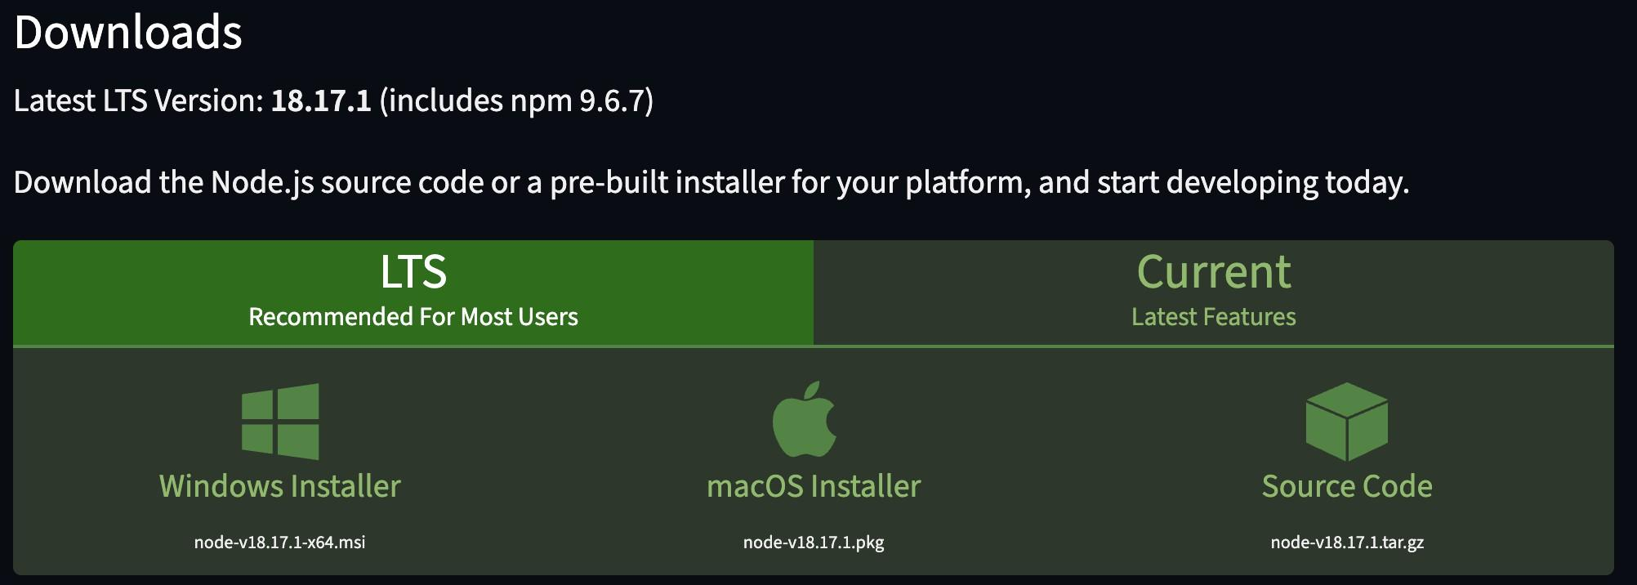

It is recommended that you install the LTS version. This is intended for most users due to stability. To confirm installation, you can open your terminal and check the version of your node.js.

It should show version 18.17.1 like the figure below.

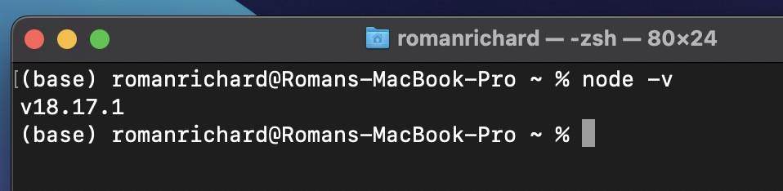

- Create a new React Native project called “awesomeProject” using expo. Run the command npx create-expo-app awesomeProject

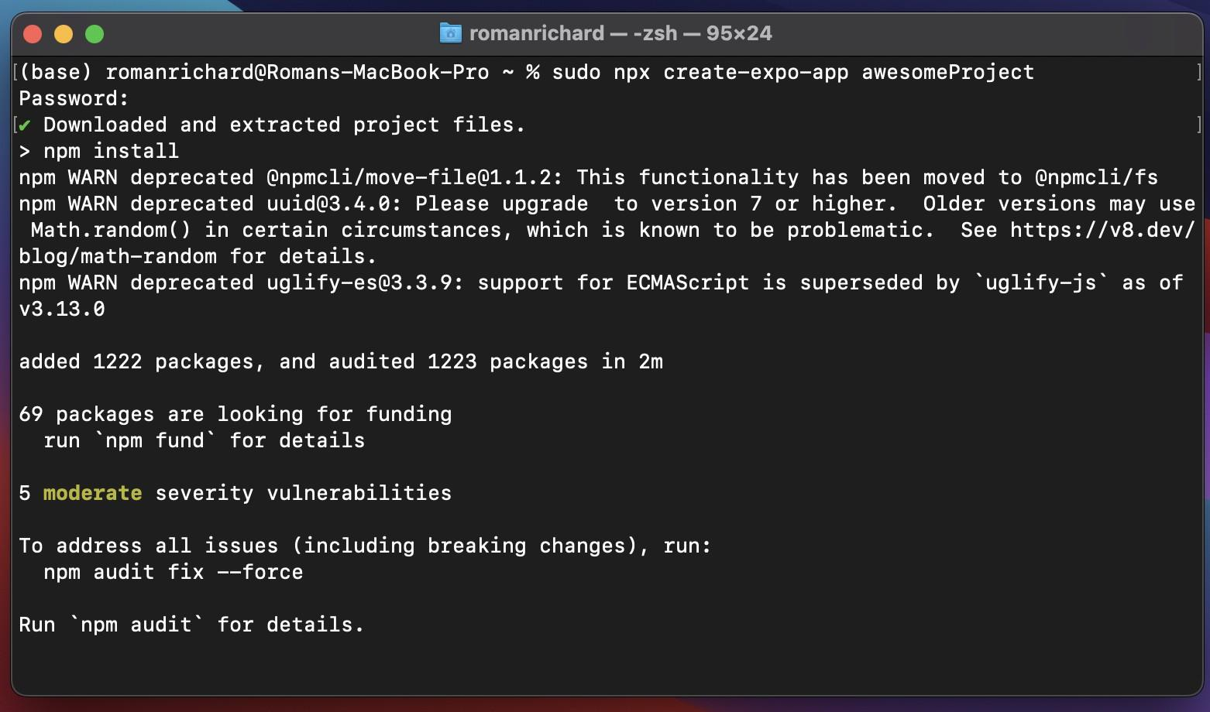

Let expo install dependencies such as shown in the figure. If you’re able to achieve something similar to the screenshot below, then you can proceed to the next step.

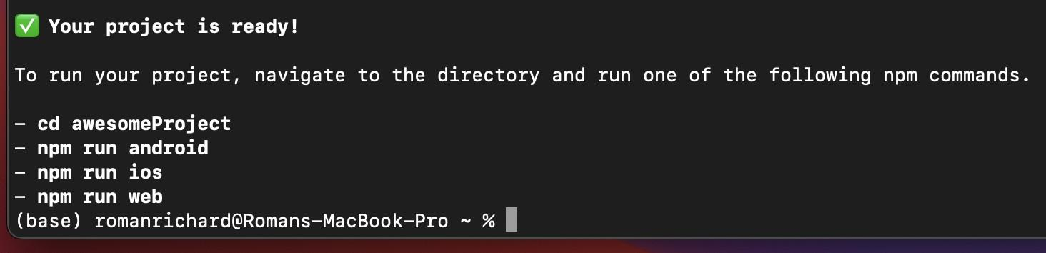

3. Run expo using npx expo start.

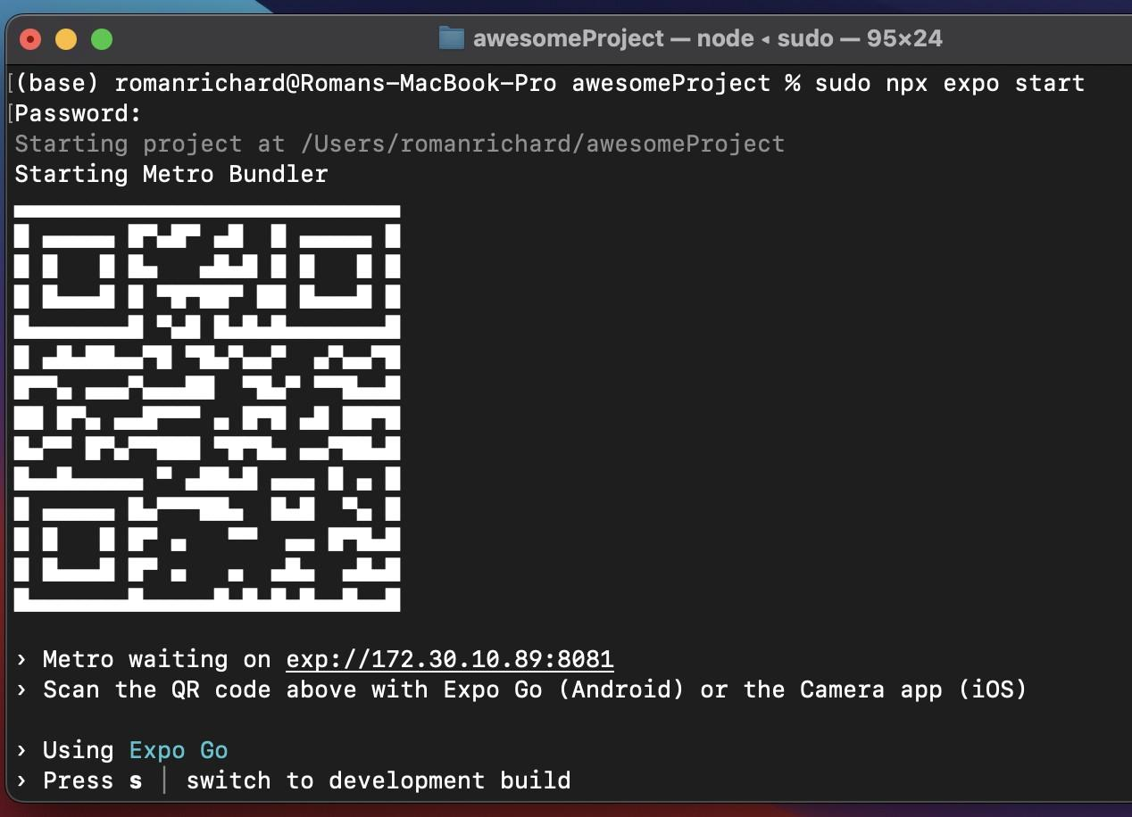

Make sure to download Expo Go on your phone to scan the code shown to connect. Alternatively, you can also input the shown socket.

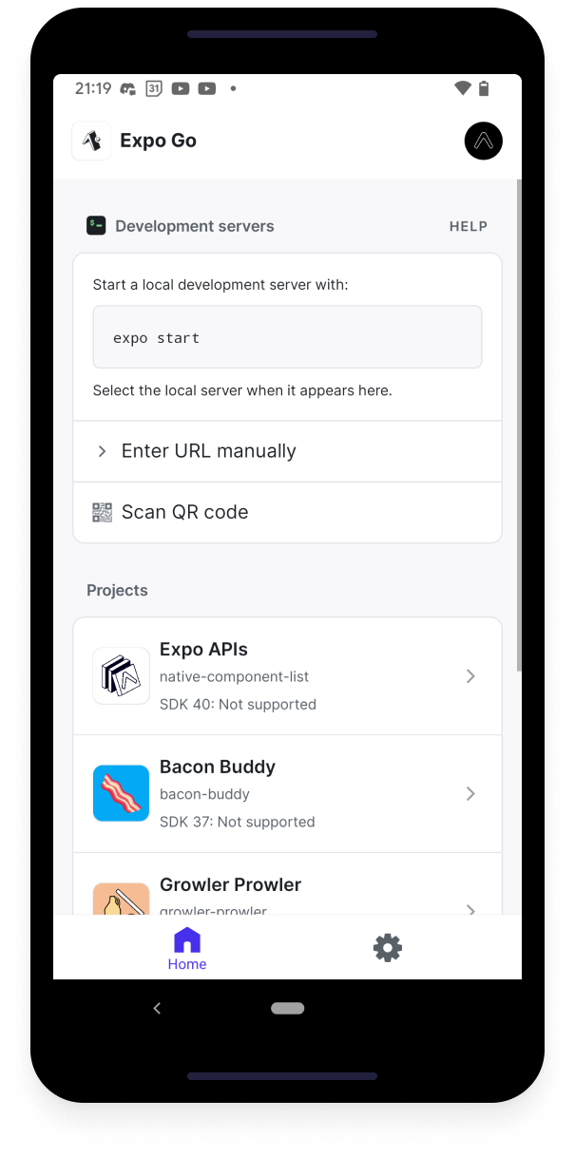

The following sections will have no screenshots provided as a guide, you are expected to include all your answers here under section 6: output.
- Open VSCode (or any compatible editor) and explore the folder.
- Provide a quick summary of the contents of the awesomeProject application.
6. Output
Provide an output of your work here.

Setup
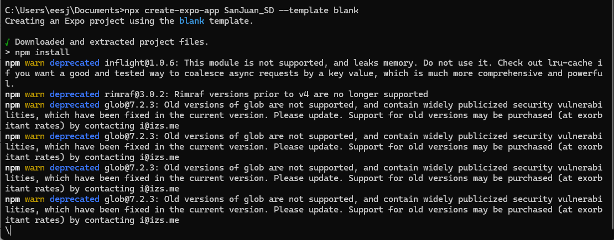
Change directory to your created folder and run vscode
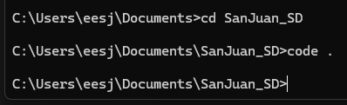
Creating Github Repository
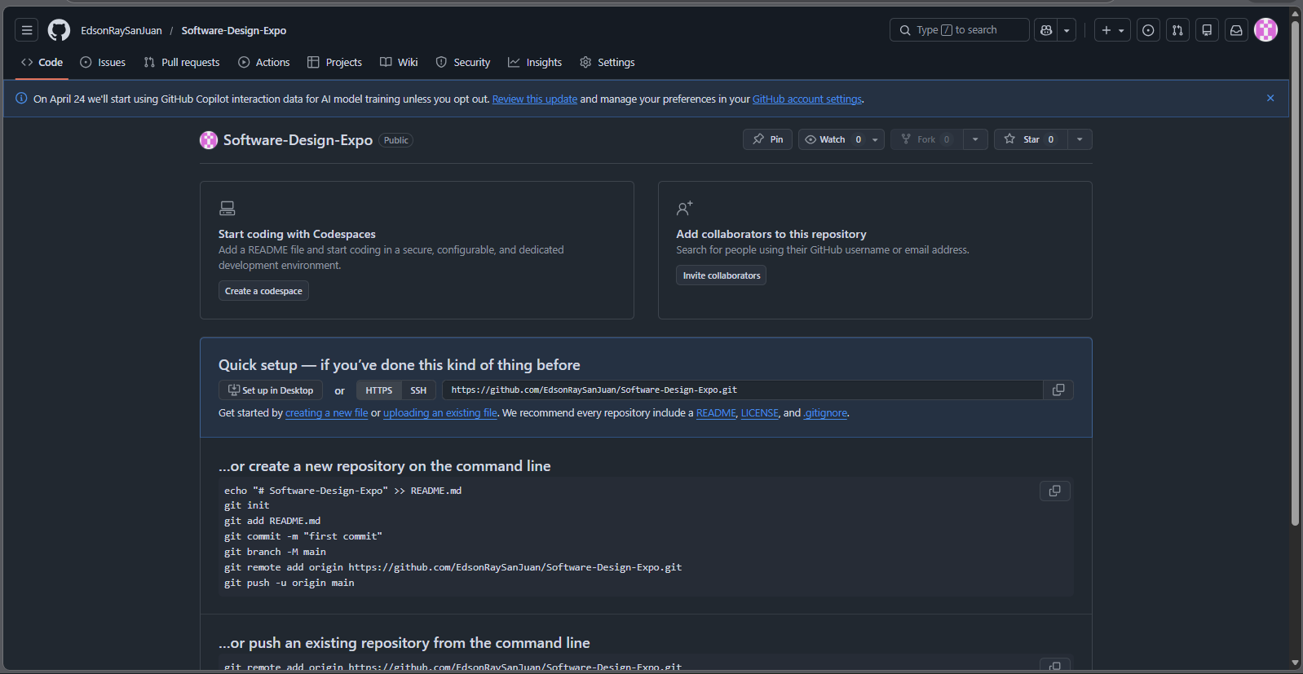
Linking VSCODE to Github
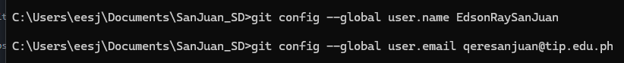
Initialize and connect the github repository in vs code
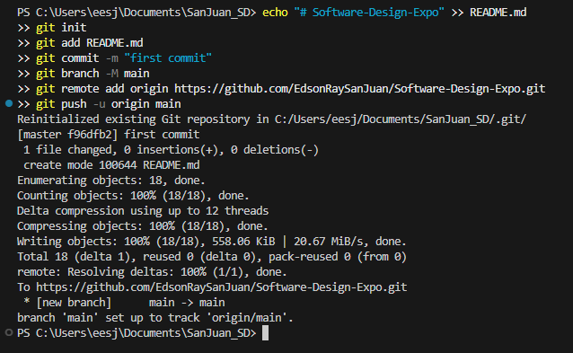
To run the App.js enter the command npx expo start
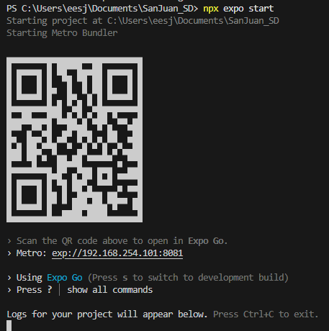
To run in the browser (Optional)
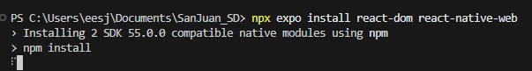
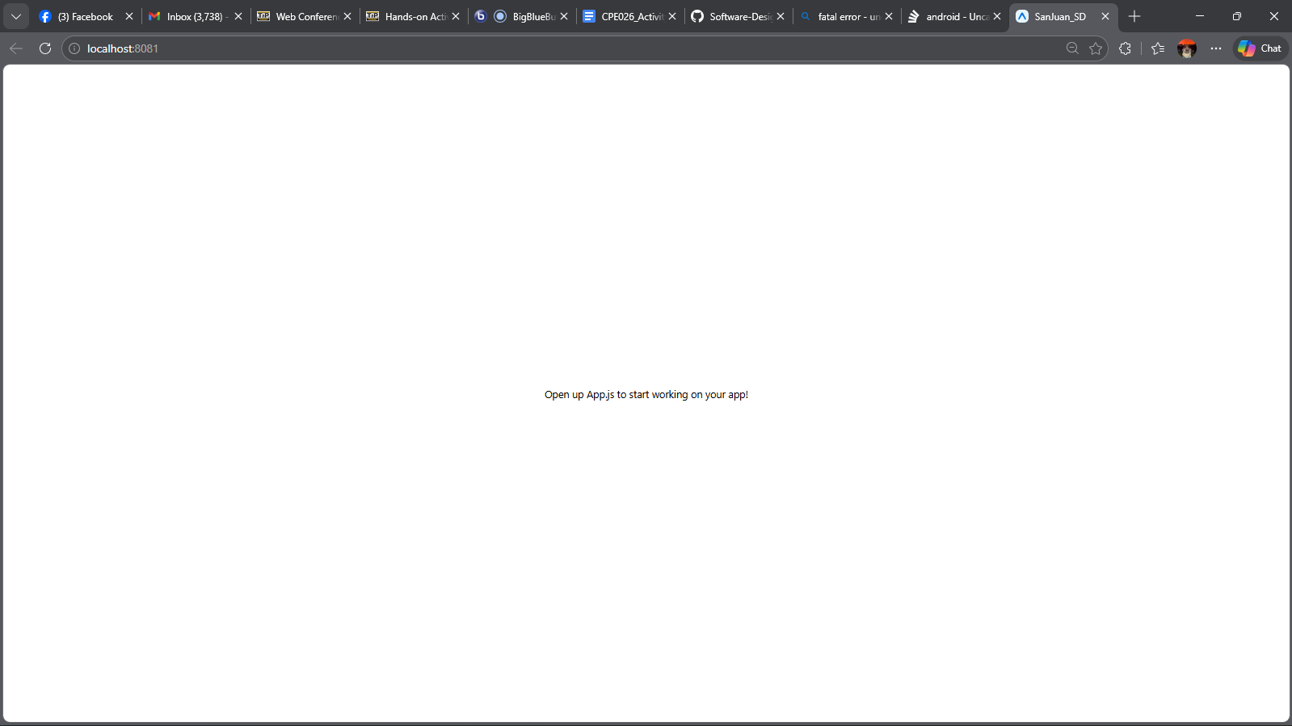

fatal error - uncaught error: java.ioexception: failed to download remote update
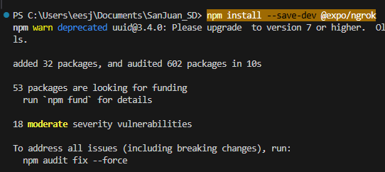
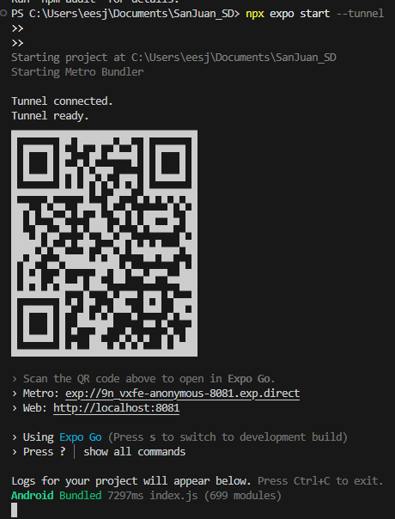
Verification in Phone that it works
Expo Go in Phone (Connected)
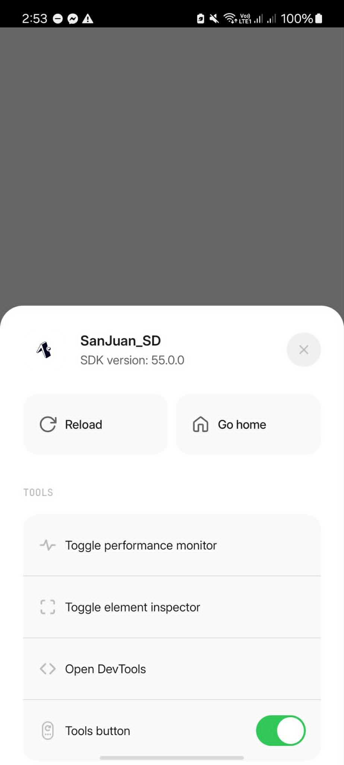

7. Supplementary Activity
Modify app.js to reflect all names of the members of the team. This change must then reflect on your live demo. Provide the following:
- What did you change in app.js?
- On my modified code, I did a simple Facebook login sign‑up look‑alike. I placed the contents — like the rectangle card and the text inputs for username and password — inside a formContainer so they sit neatly in a square card. Then I adjusted the container’s fixed dimensions, centered it, and added basic styling such as background color, padding, and rounded corners to make it resemble the Facebook login/sign‑up user interface. The “facebook” title sits above the card, while the inputs, action button, and toggle link are grouped inside.

- Provide a picture of the live demo on Android and iOS device.
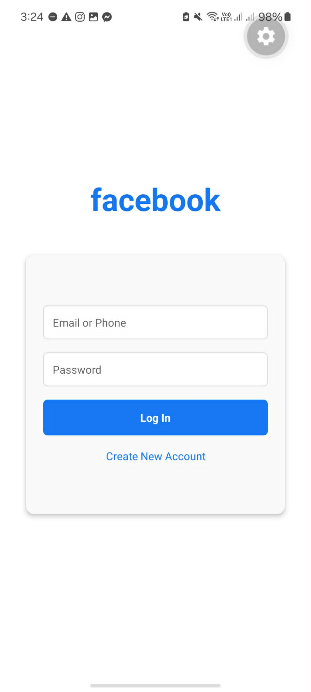

// HOA 10.1 (Mar. 27, 2026)
import React, { useState } from 'react';
import { Text, View, TextInput, TouchableOpacity, StyleSheet } from 'react-native';

export default function App() {
const [isLogin, setIsLogin] = useState(true);

return (
<View style={styles.container}>

<Text style={styles.title}>facebook</Text>

{/* Form Container */}
<View style={styles.formContainer}>
<TextInput
placeholder="Email or Phone"
style={styles.input}
/>

<TextInput
placeholder="Password"
secureTextEntry
style={styles.input}
/>

{!isLogin && (
<TextInput
placeholder="Confirm Password"
secureTextEntry
style={styles.input}
/>
)}

<TouchableOpacity style={styles.button}>
<Text style={styles.buttonText}>
{isLogin ? "Log In" : "Sign Up"}
</Text>
</TouchableOpacity>

<TouchableOpacity onPress={() => setIsLogin(!isLogin)}>
<Text style={styles.switchText}>
{isLogin ? "Create New Account" : "Already have an account?"}
</Text>
</TouchableOpacity>
</View>

</View>
);
}

const styles = StyleSheet.create({
container: {
flex: 1,
justifyContent: 'center',
backgroundColor: '#f0f2f5'
},
title: {
fontSize: 42,
fontWeight: 'bold',
color: '#1877f2',
textAlign: 'center',
marginBottom: 30
},
formContainer: {
backgroundColor: '#fff',
width: 300,
height: 300,
alignSelf: 'center',
padding: 20,
borderRadius: 8,
justifyContent: 'center'
},
input: {
borderWidth: 1,
borderColor: '#ccc',
padding: 10,
marginBottom: 15,
borderRadius: 4
},
button: {
backgroundColor: '#1877f2',
padding: 12,
borderRadius: 4,
alignItems: 'center'
},
buttonText: {
color: '#fff',
fontWeight: 'bold'
},
switchText: {
marginTop: 15,
textAlign: 'center',
color: '#1877f2'
}
});

8. Conclusion
In conclusion, I did a simple Facebook login/sign‑up look‑alike. I grouped the inputs and buttons inside a formContainer to give it a fixed square dimension, then centered it, and added basic styling like background color, padding, and rounded corners. The “facebook” title sits above the card, while the username, password, confirm password, action button, and toggle link are neatly organized inside. Overall, I transformed the default layout into a clean, square card design that mimics the Facebook login page.
9. Assessment Rubric

